ASAASIAM VISION INTERNATIONAL
P.O. BOX NJ 390, Nkawkaw
Tel: Main office: +233 200030441 / +233 302965317

Email: info@asaasiamvision.org
Website: https://asaasiamvision.org/index.php
Let Girls Excel Africa Program Activities - 2025
1. Introduction
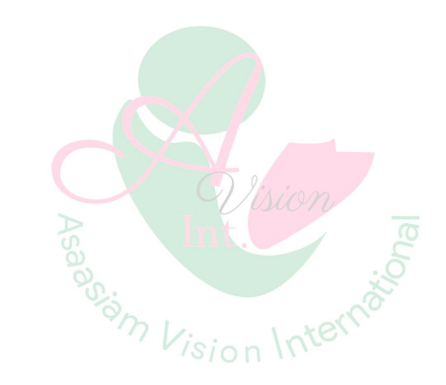
The Let Girls Excel Africa program by Asaasiam Vision International empowers vulnerable girls aged 11-18 in rural Eastern Ghana through education support, leadership training, menstrual health education, and safe emotional sharing spaces. Key objectives of the program include improving school retention, building confidence and leadership skills, eliminating period poverty and stigma, and creating school-based clubs for sustained peer support.
2. Leadership & Team
Programs were led by Theresa Frempomaa Somuah, Programs Director, with support from Joseph Asare, a Director of the organisation, Alodie Didier, Sharon Brabenac 20 volunteer teachers across partner schools.
This report details six programs reaching 140 girls
Program 1: Oda Frimpong Manso JHS
1. Number of beneficiary girls
30 girls
2. Activities undertaken
o Girls' education & career session (importance of education, academic goal setting)
o Menstrual health education (body changes, hygiene, stigma reduction)
o Sanitary pad distribution and dignity discussion as well as donation of educational materials
o Teacher engagement on girls' academic support
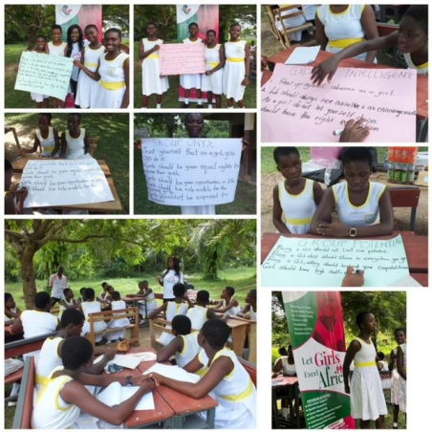
Program 2: Kwahu Hwidiem Basic School
1. Number of beneficiary girls
20 girls
2. Activities undertaken
o Leadership & confidence-building workshop o Menstrual hygiene education & pad distribution o Climate resilience awareness session
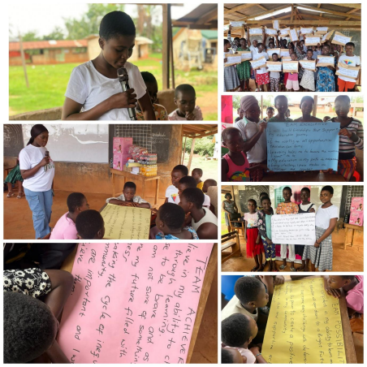
o Let Girls Excel club introduction 3.
Program 3: Islamic/Zongo Girls Program
1. Number of beneficiary girls
20 girls
2. Activities undertaken
o Culturally-sensitive menstrual health education
o Period stigma reduction for Islamic girls
o Girls' rights & education discussion
o Sanitary pad & hygiene kit distribution
o Community Leader Engagement
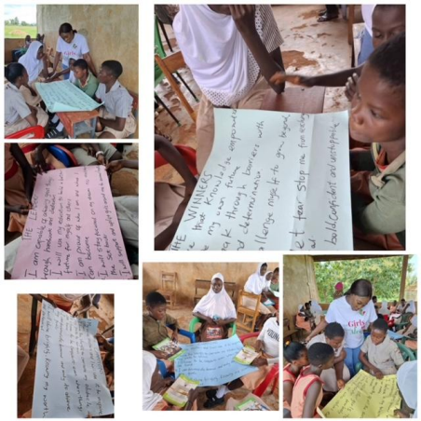
Program 4: Follow-up at Kwahu Hwidiem Basic School
1. Number of beneficiary girls
20 girls (returning cohort)
2. Activities undertaken
o Progress review & goal adjustment session
o Leadership skills reinforcement
o Menstrual health refresher & pad top-up
o Let Girls Excel club sustainability planning
o Teacher performance feedback discussion
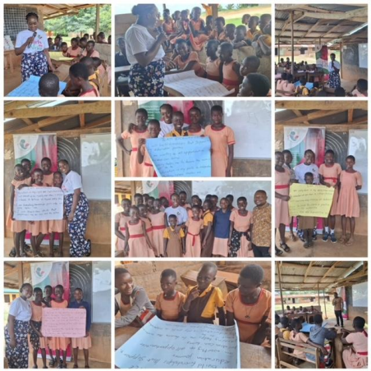
Program 5: December Time with the girls
1. Number of beneficiary girls
20 girls (within 350 total vulnerable children who attended Christamas party for the vulnerable children)
2. Activities undertaken
o Christmas celebration with meals & entertainment
o Girls' education motivational talks
o Self-esteem building activities
o Gift distribution (school items, clothing)
o Distribution of Sanitary Pads
o Parent/community sensitization
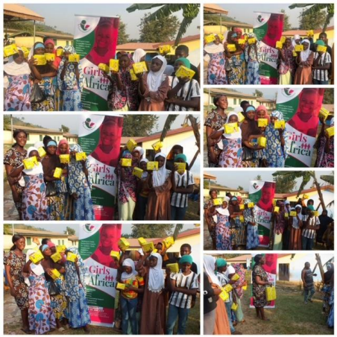
Program 6: Oda Frimpong Manso JHS
1. Number of beneficiary girls
30 girls (15 new girls + 15 from first cohort before graduation)
2. Activities undertaken
o End-of-year academic reflection
o Resilience & motivation building
o Menstrual health refresher
o Let Girls Excel club planning for 2026
o Teacher continuity discussion
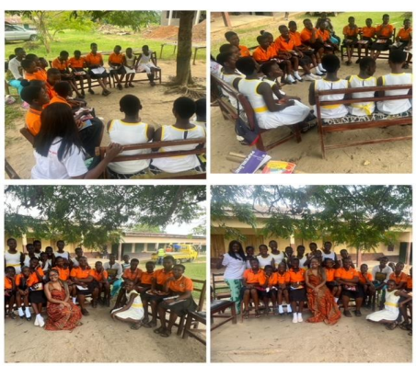
Summary Table
1  2  3  4  5  6  TOTAL | Program Location | Girls Reached  20  20  20  20  140
1  2  3  4  5  6  TOTAL | Oda Frimpong Manso 30 | Girls Reached  20  20  20  20  140
1  2  3  4  5  6  TOTAL | Kwahu Hwidiem | Girls Reached  20  20  20  20  140
1  2  3  4  5  6  TOTAL | Islamic/Zongo | Girls Reached  20  20  20  20  140
1  2  3  4  5  6  TOTAL | Hwidiem Follow-up | Girls Reached  20  20  20  20  140
1  2  3  4  5  6  TOTAL | Nkawkaw Christmas | Girls Reached  20  20  20  20  140
1  2  3  4  5  6  TOTAL | Oda Frimpong Manso 30 | Girls Reached  20  20  20  20  140

Conclusion
Let Girls Excel Africa has currently enrolled and delivered impactful programs across six targeted interventions, reaching 140 vulnerable girls with education motivation, menstrual health support, leadership training, and school girls club establishment.
Activities demonstrated strong cohort continuity (90% retention), teachers buy-in, and community trust, with school clubs now positioned for sustainability, peer leadership. Girls reported increased confidence, better menstrual health knowledge, and clearer academic goals.
3. LESSONS LEARNED FROM 2024–2025
• Girls return when safe spaces are consistent.
• Sanitary pad distribution directly reduces absenteeism.
• Teacher engagement strengthens retention.
• Community and cultural sensitivity (e.g., Islamic/Zongo program) increases trust. • Low-cost, volunteer-driven model maximizes impact.
However, one major gap persists: Lack of safe, private washrooms continues to undermine menstrual dignity and academic focus. This is why 2026 integrates infrastructure into the empowerment model.
2026 Way Forward
4. THE 2026 INTEGRATED SAFE SPACE MODEL The 2026 model builds on success and adds infrastructure for permanent impact. Three Integrated Components
1. Physical Safe Space – Construction of 3 Girls’ Washrooms
Our experience from engaging with the girls have shown that most of the schools do not have washrooms for girls. This makes it very difficult for the girls to change when the encounter period emegencies.
Each washroom will include 2–3 private cubicles, changing room, water storage, handwashing station, sanitary disposal, lockable doors, ventilation, and donor recognition plaque. Each facility will be named after the donor supporting it.
2. Emotional Safe Space – Monthly Circle Sessions (April–December) 9 Circle Sessions where girls sit in a circular format and discuss academic goals, cultural pressures, menstrual challenges, leadership identity, fear, confidence, and aspirations. Volunteer facilitators will run sessions. The purpose of the session is to build emotional safety, strengthen peer networks, improve self-expression, increase self-worth.
3. Academic, Health & Leadership Empowerment
• Education: Goal setting, study techniques, overcoming academic barriers, education counselling.
• Health: Menstrual health education, hygiene awareness, pad distribution, pad banking exploration.
• Leadership: Confidence building, climate resilience, cultural perception dialogue, peer-to-peer coaching.
• Career Mentorship: Role model engagement, career exposure talks, mini–Career Fair.
• Community Engagement: Parent sensitization, girls’ rights education, early marriage dialogue, club strengthening.
5. TARGET BENEFICIARIES
Direct: 250–400 girls (ages 11–18)
Indirect: Teachers, parents, community leaders
6. IMPLEMENTATION TIMELINE (2026)
Period | Activities | Details & Actionable Steps
Q1 March | - School selection  - Baseline survey  - Stakeholder meetings - Construction planning | - Identify 3-5 schools via community leaders; site visits by Mar 15.  - Design & deploy survey to 200 girls; analyze data by Mar 31.  - Schedule meetings with principals, parents, local govt; confirm commitments.  - Architect designs for 3 washrooms; secure permits by month-end.
Q2 (April–June) | - Circle Sessions begin - Education & health  workshops  - Washroom 1  construction &  commissioning | - Train 10 facilitators; launch 10 weekly sessions per school.  - Partner with NGOs for 4 workshops; reach 140 girls.  - Tender & start build on Washroom 1; handover by June 30 with training.
Q3 (July–  September) | - Leadership modules - Pad distribution  expansion  - Washroom 2  construction  - Parent forum | - Roll out 6 modules with peer leaders; certify 50 girls.  - Procure & distribute 1,000 pads; monitor usage.  - Complete Washroom 2 build; quality inspection mid-Sep.  - Host forums in 3 schools; gather 100 parents for feedback.
Q4 (October–  December) | - Career mentorship & mini fair  - Washroom 3  construction  - Endline survey  - Graduation &  recognition event | - Invite 20 mentors; organize fair for 140 girls. - Finalize Washroom 3; operational by Nov 15.  - Repeat baseline survey; compare results by Dec 1.  - Celebrate top performers; issue certificates Dec 20.

7. EXPECTED OUTCOMES
By December 2026:
• 3 fully functional girls’ washrooms
• 9 Circle Sessions completed
• Reduced menstrual absenteeism
• Improved attendance rates
• Increased leadership participation
• Strengthened school clubs
• Higher self-confidence scores
• Stronger community advocacy
8. MONITORING & EVALUATION
Baseline & endline surveys, attendance tracking, menstrual absenteeism tracking, focus groups, teacher feedback, club activity monitoring.
9. SUSTAINABILITY STRATEGY
School maintenance committees, Parent Teacher association involvement in washroom upkeep, established school clubs, volunteer facilitation model, annual donor reporting, community ownership agreements.
10. 2026 BUDGET SUMMARY
Total Funding Required: $18,750
Category | Items | Amount
A. Infrastructure – 3  Washrooms | Materials  Skilled labor  Plumbing  Water systems  Doors, fittings  Disposal system  Donor plaques | $13,800
B. Direct Support to Girls | Sanitary pads (bulk purchase) Hygiene kits,  Educational materials  Books & stationery and Experiential learning materials  Career fair materials | $4,520
C. Program  Implementation & M&E | Transport and Logistics  Printing materials  Monitoring tools  Community engagement sessions | $320

11.PROGRAM VALUE PROPOSITION
Donors will receive naming rights for washrooms, recognition plaque, commissioning ceremony, social media & website acknowledgment, impact report with data & stories, visibility through award-recognized leadership.
12. CONCLUSION
Let Girls Excel Africa has proven impact and strong leadership. 2026 program moves from short-term interventions to permanent safe space transformation.
With your support of $18,750, we will build dignity, protect education, empower leadership, create safe spaces, and change futures of vulnerable and underserved girls in Africa.

